A guide to local support for help with food, finances, and debts

You can contact Salford Citizens Advice crisis line on 07494 498693
To contact Adult Social Care between 8.30am and 4.30pm from Monday to Friday:
- Telephone: 0161 631 4777
- Email: salford.socialservices@nca.nhs.uk
- Text: 07970 134894
Alternatively, see the below organisations that can also offer support and guidance.

You can also contact Salford Foodbank directly by Phone on 0161 637 2120 or Email us info@salford.foodbank.org.uk

Salford Food Banks
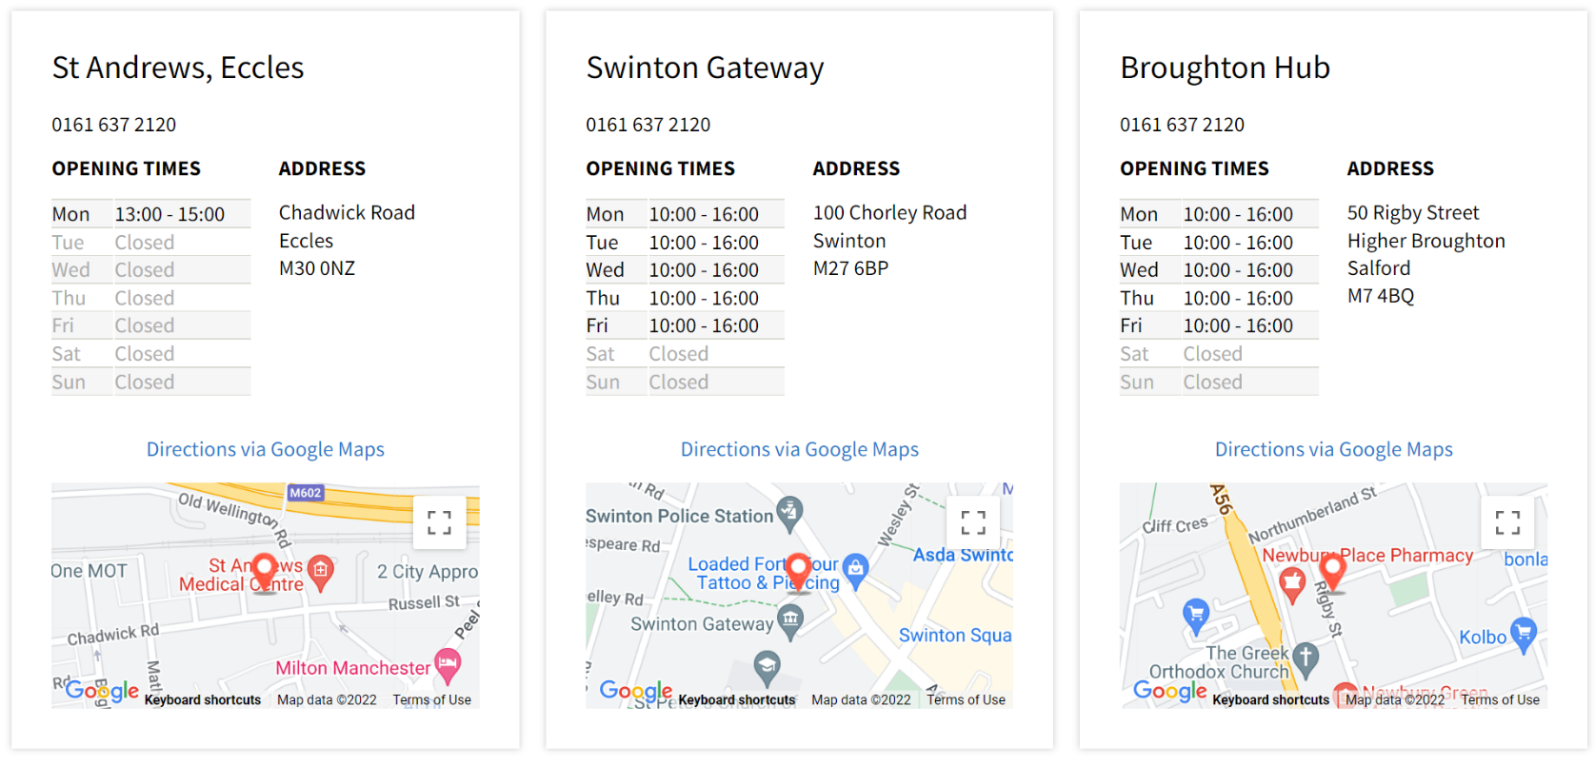
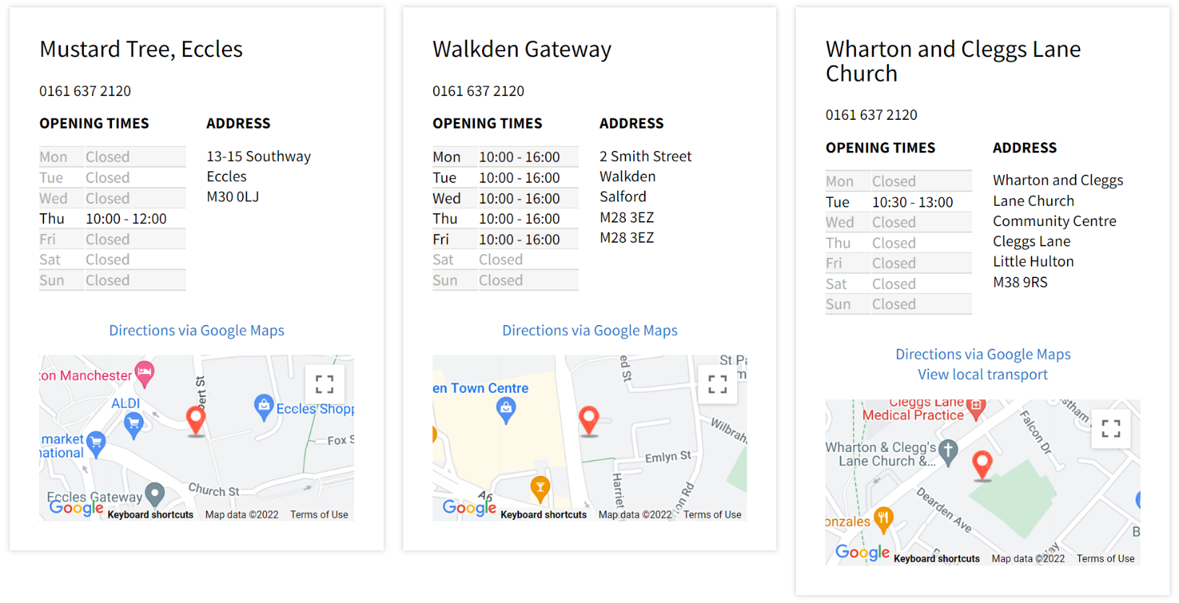
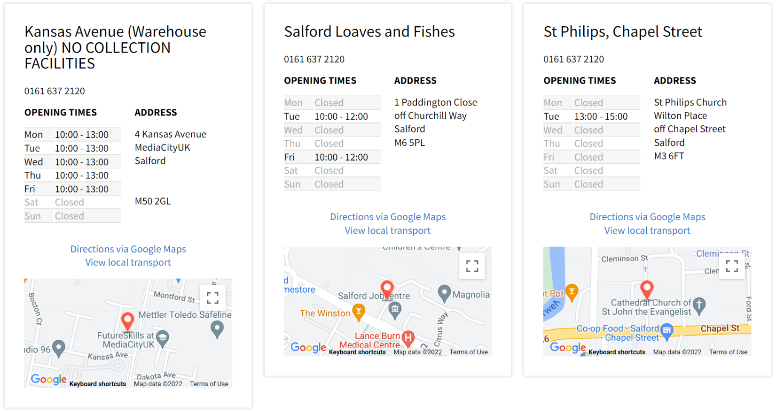

MEETING YOUR NEEDS
Your foodbank voucher/code will be exchanged for three days of emergency food. We want to make sure that we give you the right food to meet your needs.

PREPARING YOUR FOOD
Your food will be handed to you in pre-prepared parcels. At some of our centres you will be able to a enjoy a warm drink, and if you want to, have a chat with the volunteers or get advice on your financial situation with one of our professional advisers. At Swinton and Walkden Gateways and at Broughton Hub, they will advise you on other services available.
The welcome is different, but just as caring.
Your food parcel will be packed into supermarket carrier bags. If you prefer to bring your own bags those can be used instead.

PRACTICAL GUIDANCE AND SUPPORT
On your visit to us, if you need support beyond the food, you can speak to volunteers who will try to help you through other issues or a professional adviser who will be at our sessions, as part of our new LAMPS (Learning About Money Problem Solutions) project.


The project is now open serving free hot meals 9am - 2pm Monday to Friday with indoor and outdoor seating available. Support staff are available Monday to Friday 9am-2pm.

1 Paddington Close, Salford, M6 5PL 0161 737 8775

Eccles

Mustard Tree Food club

Evidence required: ID and proof of benefits for Food Club

12 Southway, Eccles, Salford, M30 0LJ

Telephone number: 0161 228 7331

Email: referrals@mustardtree.org.uk

Opening times: Monday, Tuesday, Wednesday and Friday (10am-2pm).

http://www.mustardtree.org.uk/

The Bread and Butter Thing

Membership Pantry

Barton Moss, Barton Moss Primary School, Trippier Rd, Eccles. M30 7PT

Email: hello@breadandbutterthing.org.uk

https://breadandbutterthing,org/

Brookhouse Food Club (Bless Manchester)

Brookhouse Community Centre, Buckthorn La, Eccles, M30 7QH

£5.00 annually (can be paid in installements) and £3.00 per visit (£10-15.00 worth of goods can be purchased for the £3.00 fee).

Contact details: Barry Matley 0161 736 7959. Simon or Wendy Litchfield on 0161 786 1440

Opening times: 12pm-2pm on Mondays from August

Higher Broughton

St James Community Lunches

Great Cheetham Street East, M7 4UH

Wednesday, Thursday and Friday 11:00am-1:00pm

Food pantry open to all. No ID needed, customers choose 10 items of food for £2.50

Little Hulton

Mustard Tree Food Club

50 Hulton District Centre, Little Hulton, Salford, M28 0AU

Telephone number: 0161 228 7331

referrals@mustardtree.org.uk

Monday, Tuesday, Wednesday and Friday (10m-2pm)

Community Little Hulton

Little Hulton 27, District Centre, Little Hilton, M28 0AU

Open 9.15am to 2:00pm every Wednesday

£2.50 per 12 items of food

communitylittlehulton@communitylittlehulton.co.uk

Orsdall

The Bread and Butter Thing

Membership pantry

Orsdall Community Café, 172 Tatton Street, Salford, M5 3PS

hello@breadandbutterthing.org

https://breadandbutter.org.uk/

Salford

The Angel Centre,

The Angel Centre, 1 St Phillips Place, M3 6FA

The cost is £2.50 and all Salford residents are welcome- call into the centre and fill in a membership form

The service is value for money and goods usually totally up to around £20.00

Open 9.30am to 4.00pm Tuesday – Thursday

https://www.theangelcentre.org,uk/angel-centre/Salford

01617101075

Audacious A-Teams

No evidence required

Audacious Church, Deva City Office Park, Trinity Way M3 7BB

Telephone number: 0161 830 7007

Opening times: Tuesdays 7:00pm-9:00pm Hot 3 course meal (Also have a barbers and clothing)

Thursdays 10:00am-12:00pm Breakfast

For those experiencing homelessness and street homeless

Family FoodFayre

Food Club, Windsor Christian Centre, Churchill Way, M6 5BU

Costs are £5.00 membership and £3.00 per shop

Opening times: Mondays 11:00am-3.00pm and Thursdays 1:00pm-5:00pm

barry@manchestercitymission.org.uk

Contact number: 0161 736 7959

https://citymission.org.uk/

Victory Outreach Manchester

19 Liverpool Street, Salford, M5 4LY

£5.00 membership for the year and from £4.00 per visit

Fill your basket with Fruit, veg, chilled and toiletry items 3 times a week

Opening times: 9.30-4.30pm Monday to Friday

Contact number: 0161 987 6511

https://www.facebook.com/communitygrocerysalford/

email: salford@communitygrocery.org.uk

Salford Quays

Oasis Hub MediaCityUK Community Food Store

Oasis Hub MediaCityUK, Trafford Road, Salford, M50 3UQ

Annual membership fee of £5.00 which will include the cost of your first week’s food

£3.50 per week- you can select 10-12 items

They provide fruit and vegetables, and some shorter dated items, for free, on top of this fee.

Contact details: Hannah Miller, Hannah.miller@oasismediacityuk.org

Contact number: 07557076649

Opening times: Wednesday 10.30am-2:00pm, community café throughout the day

www.oasishubmediacityuk.org/food-store

Swinton

The Bread and Butter Thing

Membership pantry

Please make contact for further details

St Peters Church, Chorley Road, Swinton, M27 0WA

Contact details: hello@breadandbutterthing.org

https://breadandbutterthing.org/

Household Support Fund • Salford City Council

Who is eligible for support?
Salford residents do not need to be in receipt of benefits to apply for the Household Support Fund, however applicants will need to provide evidence that they do not have the funds themselves to purchase the items requested.

How to apply
Apply now for the Household Support Fund
Please note that various information is required to complete the application such as your current energy supplier, a recent bank statement and Universal Credit Journal (where applicable).
The application also covers questions related to personal demographics to help us ensure that all communities in Salford are supported.
The application deadline is 30 September 2022.

What can the Household Support Fund help with?
The support will mostly be awarded by way of a grant payment (via vouchers) to those eligible to assist with things like:
- purchasing food
- financial support for energy, water and utility bills
- help to heat homes
- other essential items and support
Salford City Council are committed to ensuring vulnerable residents are supported in the best way possible and the Household Support Fund will mirror the support Salford City Council offer via their Discretionary Support Scheme - Salford Assist, in the way that all reasonable requests for support will be considered. This could be for:
- household items
- white goods
- carpets or thermal curtains to keep home warm

2 https://www.emmaus.org.uk/salford/luciespantry
Lucie’s Pantry is a social supermarket located at the main Emmaus Salford base on Fitzwarren Street in Pendleton.
Our Pantry provides a sustainable and affordable source of food and household essentials to members of the Salford community struggling to make ends meet through debt, illness or low income. Together we’re providing great food for great people.

How does it work?
People who want to use the social supermarket become a member of Lucie’s Pantry. Members pay £3 per week and are able to choose their weekly shopping to the value of roughly £20. In addition to food and household items, members are offered additional support from partners including Citizens Advice Salford and Salford Primary Care Together.
Membership is limited by need and geographical distance to the pantry. We have steadily increased membership and currently have the capacity for 250 members. Once signed up, members are allocated a weekly time slot to come and do their shopping. Lucie’s Pantry is open every week, Monday to Friday (9am-3pm).

How can I become a member?
To become a member all you need to do is complete a short application form available online here, or from Lucie’s Pantry, Citizens Advice Salford, Salford Jobcentre Plus, and local housing providers.
By becoming a pantry member, individuals help to support others in their community. The more members who use the social supermarket, the greater range of items can be sourced, allowing more people to benefit from a wider choice.

3. Salford Assist
Help when you really need it
Salford Assist is a Salford City Council scheme that can offer short term support to people who are in a crisis, emergency or major disaster situation. These situations can mean that you are unable to meet the basic needs of yourself or your family. Salford Assist doesn’t offer cash payments, but would consider your immediate needs and try to help with essential items such as:
- essential furniture items, for example a bed, or white goods
- help with emergency supply of gas or electric where there is no heating in the household
- advice and referrals to another service, agency or fund
- council tax support
- copies of birth certificates for homeless people
Assistance may also include things such as seeking debt advice, referral routes to affordable loans and recycled furniture schemes. We also give advice on how to access more affordable fuel tariffs and benefits.

Our awards are discretionary
This means there will be no duty on the council to make an award, each application will be considered on its merits. All other options for support should be investigated before an application is made. The scheme is linked to other support services including homelessness prevention, debt advice, welfare rights, money management skills, affordable loans and council tax.
Applying is easy. Please contact the team on 0800 694 3695 or complete an online application form if you meet some simple criteria. You will need to:
- show you don't have access to sufficient income or savings or receive a qualifying means tested benefit
- be prepared to apply for support from other agencies where appropriate

It’s really important to include the following when submitting an application form:
- proof of identity and you are over 16 years old
- a recent bank statement (from the last four to six weeks)
- a copy of any entitlement/delays to benefits letters
- a signed copy of the declaration form and sharing agreement / privacy notice

How to apply for Salford Assist
- Call the Salford Assist Helpline on 0800 694 3695 from 10am to 4pm Monday to Friday
- Submit the online application form below

Council Tax Support - If you are liable to pay council tax in the Salford City Council area you may be able to get temporary help with your council tax in accordance with the terms of Section 13A of the Local Government Finance Act 1992.

4. Contact the Welfare Rights and Debt Advice Service

How to contact us for advice or representation

Online - You can refer yourself or another person for welfare rights and/or debt advice or representation via our online referral form.
If you are completing this for another person you may need them with you in order to fully complete their personal details.
Complete our online referral form

Other routes to debt advice or representation

By telephone - The debt advice service provides advice for people who have complex/priority debts or a need for debt related court representation.
If you would prefer to talk to someone on the telephone about debt advice or representation you can ring our debt advice line on 0800 345 7323. This is open Mondays and Wednesdays between 1pm and 4pm and 9.30am to 12.30pm on Fridays apart from Bank Holidays. It is not possible to leave a voicemail outside of those hours.
If you have a single debt or non-priority debts please contact an agency that can advise you. These include:
- National Debtline
- Step Change

Other routes to welfare rights advice or representation

By telephone
If you would prefer to talk to someone on the telephone about welfare rights advice or representation you can ring our welfare rights advice line on 0800 345 7375. This is open Monday to Friday between 10am and 12pm (midday) apart from Bank Holidays. It is not possible to leave a voicemail outside of those hours.

Via your GP practice or health centre
Alternatively you can ordinarily make an appointment to see a welfare rights officer via your GP surgery or health centre if you see a GP at:
- Mosslands Medical Practice - 0161 776 0737
- Lower Broughton Health Centre - 0161 983 0016
- Newbury Green Health Centre - 0161 983 0800
- Langworthy Medical Practice - 0161 737 9244
- Ordsall Health Surgery - 0161 983 0080
- Silverdale Medical Practice - 0161 983 0940
- Springfield Medical Centre - 0161 871 2450
Ring the reception of your centre, practice or surgery and ask for the next available appointment with a welfare rights officer. Other types of appointment may be available if there is no alternative.
5. BetterOff in Salford


BetterOff Salford is about helping everyone in the city with the cost of living crisis and finding ways for residents to become better off. It’s part of our plan to create a better and fairer Salford by tackling poverty and inequality.
We’re here to help residents and businesses, providing both face to face and online support. You choose what’s right for you. Talk to a trusted face in a local place at one of our Gateways or book a one to one video chat. For 24/7 support, check out our Better Off website which is an easy way to find out if you’re entitled to benefits and help you apply for them online. You can also find more details about help with the cost of living in the March 2022 edition of Life in Salford.
We might not be able to solve all your problems but there are lots of ways for you to get help. Whether you’re worried about benefits, debt, financial assistance, housing, health or wellbeing, or just need help getting online, chat in confidence with one of our friendly advisors.
Don’t suffer in silence, just get in touch. You can also call our Spirit of Salford helpline on 0800 952 1000 or complete an online form.


What we do
We provide free debt advice, to help you deal with your debt and set up a solution. We’re here to help you.
You can easily switch between getting debt advice from us online or over the phone. Either way we'll follow a simple, three-step process to deal with your debt:
- We’ll help you work out your budget, income and debts
- We’ll use this information to find a solution to your debt that suits your situation
- We’ll set up your debt solution, and offer support however long it's needed
Our online debt advice service is available 24 hours a day 7 days a week, at a time that suits you.
If you'd prefer to speak to someone, you can call our debt advice helpline.
- Online debt advice service
Available 24 hours a day, 365 days a year
- 0800 138 1111
Monday to Friday 8am to 8pm and Saturday 8am to 4pm

