MATHS GCSE-SUMMER 2022- STUDENT STUDY SUPPORT
PEARSON EDEXCEL  GCSE (9-1) | Link to download specification
Mathematics | https://qualifications.pearson.com/content/dam/pdf/GCSE/mathematics/2015/specification-and-sample-assesment/gcse-maths-2015-specification.pdf

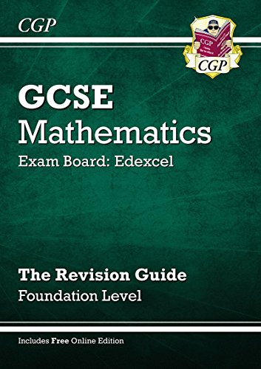
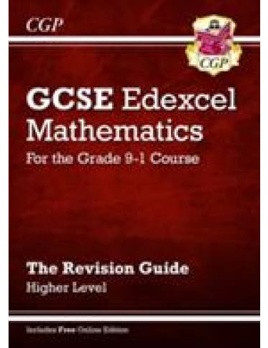

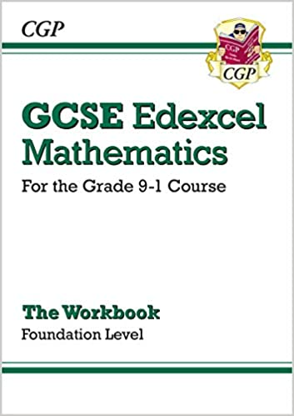
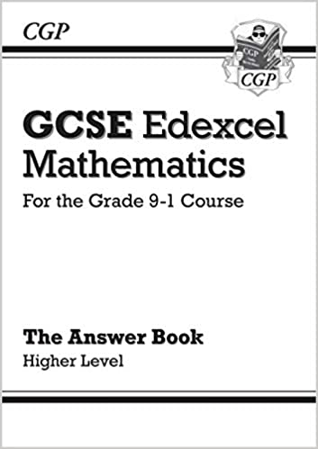
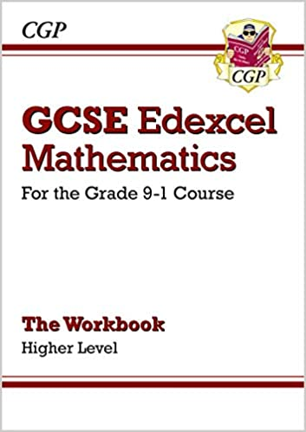
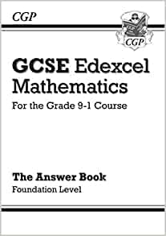

Above are some examples of revision guides and workbooks for practise towards preparation for exams

How will I be assessed?
You will sit three papers from Edexcel GCSE. Paper 1 is non-calculator, papers 2 and 3 are calculator. All papers are equally weighted out of 80 and the total from all 3 papers out of 240 will decide your grade. The exams are 1 hour 30 minutes each and will cover all aspects of mathematics including number, algebra, shape and space, geometry, ratio and proportion, data handling.
Revision Resources:
www.mathsgenie.co.uk
www.corbettmaths.co.uk
These are online resources which provide concise information, videos, exam questions, booklets and written answers, also, a wealth of other revision tools for mathematics. Mathsgenie has past exam papers, mark schemes written answers and a video walkthrough of the exam. This resource will allow students to focus on their areas for development as it is split into grades so students can focus on the grades they are aiming for. There are videos, exam questions and solutions to.
Corbettmaths – topics can be found on any level through the search bar and it also has answers available to check work.

CGP Revision – Edexcel GCSE Mathematics (9-1)
These books are illustrated at the top of page 1
All pupils have the opportunity to purchase a revision book from school at a cost of £2.50; payable through parent pay. Alternatively, the workbooks, for practise, are available on amazon.
Methodmaths
This is our online exam paper package. Students have their own individual logins and passwords and are able to access past papers. The package marks the students work as they go along so they can see their score and grade.
All work on here helps to inform working at, and future grades. It is good for student confidence.

