
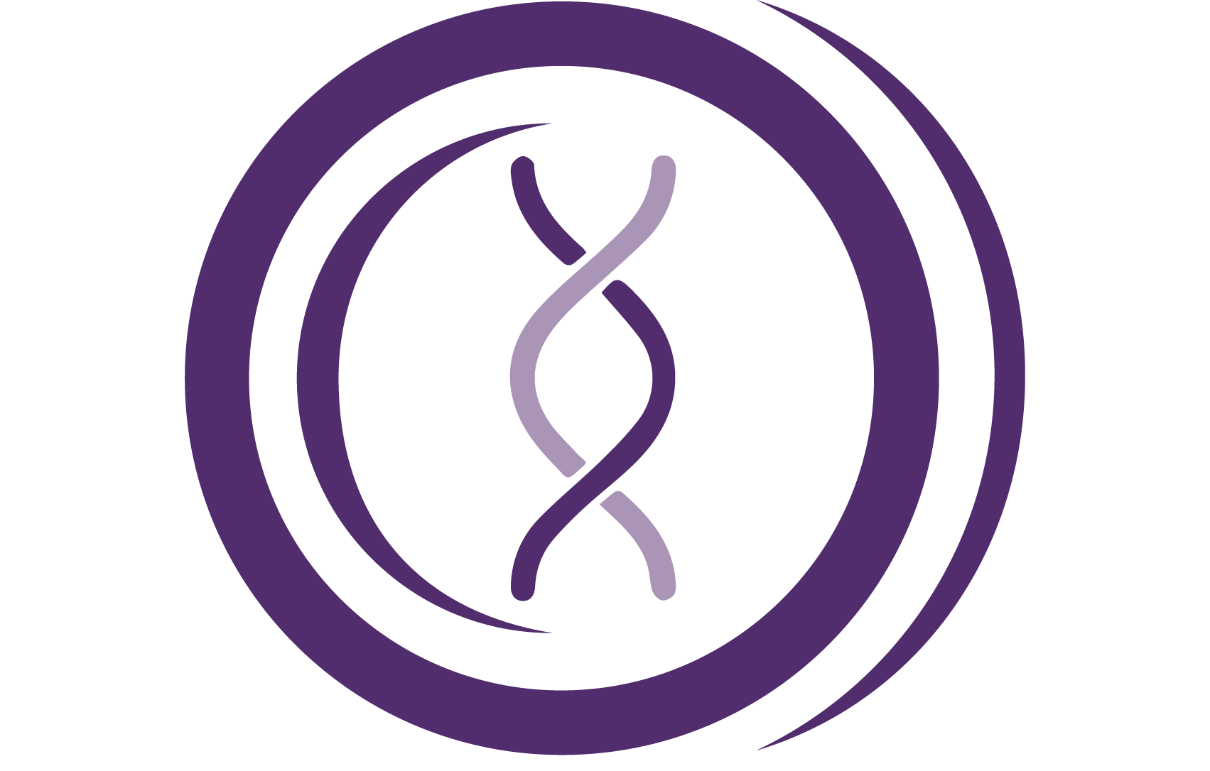

Headteacher: Mr I Ross Wentworth Road, Eccles, M30 9BP Tel: 0161 789 4565 www.ephs.org.uk
3rd February 2022

YEAR 11 ‘MAXIMISE YOUR POTENTIAL’
SUMMER EXAM INFORMATION & REVISION SKILLS

Dear Parents or Carers

In order to provide further support before your child sits their GCSE examinations this summer, students have been issued with a GCSE ‘Maximise Your Potential’ folder. This contains:

- A copy of your child’s most recent report
- Key information re summer exams
- Links to the exam specification for each subject
- This is sometimes helpful for students as it details what topics are likely to be in the exam and additional key information for each topic
- A bespoke information sheet for each subject studied
- These detail the titles and weighting of each exam
- Key information including recommended study guides and workbooks
- Useful accessible websites
- A starter pack of revision cards

Students are expected to have their folders in school each day as they will receive practice papers and additional information to support home study. These will be monitored by form tutors and students will have the opportunity to discuss any issues during this time.

All information is available on the school website under Students - Exams. See link here : http://ephs.ovw9.devwebsite.co.uk/page/?title=GCSE+Subject+Information+and+Revision&pid=104
From here, students can click on and download any specifications. The presentation shown to students is also available. This details a breakdown of each week up until the first exam. The first core examination is English Language on 18th May 2022.

Mock exams
The final set of mock exams will take place after half term. Students will receive a timetable next week. In order to ensure student shave maximum curriculum time in all subjects, assessments will be split, with some larger exams taking place in the sports hall and the remainder taking place in class. It is important for students to know that all assessments will form the basis of student’s final report before GCSE’s.

Revision and independent study
How you can support your child in structuring their independent learning in the lead up to their GCSEs?

It is proven that chunking revision into smaller sections is most beneficial to aid learning. Students should be completing at 2.5 hours of revision each day in order to retain information and practise key exam techniques. Proven successful revision strategies are provided in the maximise booklet and it would be beneficial for you to look through these with students to support them in their revision.

Headteacher: Mr I Ross Wentworth Road, Eccles, M30 9BP Tel: 0161 789 4565 www.ephs.org.uk
Other recommended resources such as CGP guides and practice work books are available on parent pay and through amazon. There are copies for all subjects in the school library for students to access before school, during lunch times and after school. Practice papers and questions, available online and from subject teachers, are a good way to practice and prepare.

Please urge your child to log their revision, in their folder, as a record of which topics and subjects they have studied out of lessons and to help with exam organisation. Revision cards are available in school, but are also available in most retail outlets.

In school revision sessions
In addition, there are revision sessions before school, at lunch times and after school which are open for students to gain additional practice, teacher support and intervention. Please see Maximise presentation and the school website for timings. Again, attendance at these sessions is highly recommended for all students.

Parents Evening
Following your child’s second set of mocks and assessments, there will be a Year 11 parents’ evening on 29th March, which will give you a further opportunity to discuss your child’s progress.

May I take this opportunity to thank you for your ongoing support.

Yours sincerely
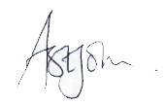
Mrs A St John
Deputy Headteacher

